Coincident Lines in Solid Geometry
# Source: AI Source: Provided by: [Data Path: Persons Table -> ID Column: 1, Name_En Column: Motasem Essam] -> From: [ChatGPT] on [7/25/2026]
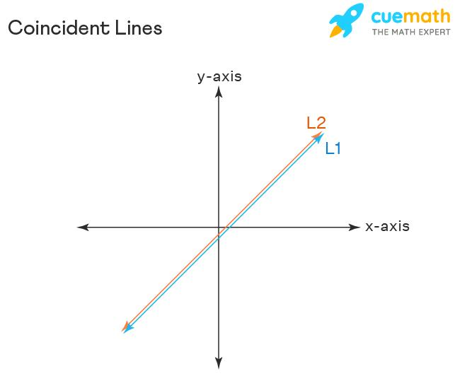

Definition
# Source: AI Source: Provided by: [Data Path: Persons Table -> ID Column: 1, Name_En Column: Motasem Essam] -> From: [ChatGPT] on [7/25/2026]
Coincident lines are two or more lines that occupy exactly the same position in space. They share every point, have the same direction, and represent the same geometric line.
In solid geometry, coincident lines may be described using different equations or labels, but if those equations define exactly the same set of points, the lines are coincident.
For example, two lines labeled $L_{1}$ and $L_{2}$ are coincident if every point on $L_{1}$ also lies on $L_{2}$, and vice versa.

Simple Definition
# Source: AI Source: Provided by: [Data Path: Persons Table -> ID Column: 1, Name_En Column: Motasem Essam] -> From: [ChatGPT] on [7/25/2026]
Coincident lines are lines that lie exactly on top of each other.
- They share infinitely many points.
- They have the same direction.
- They are not separate parallel lines.
- They are coplanar because a plane containing the line contains both representations.
Example: Writing the same straight line using two equivalent mathematical equations produces coincident lines.

Key Characteristics
# Source: AI Source: Provided by: [Data Path: Persons Table -> ID Column: 1, Name_En Column: Motasem Essam] -> From: [ChatGPT] on [7/25/2026]
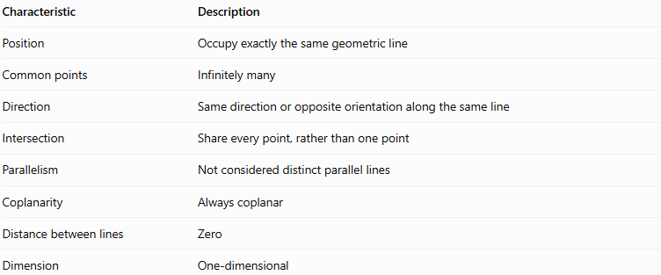
Characteristic | Description
Position | Occupy exactly the same geometric line
Common points | Infinitely many
Direction | Same direction or opposite orientation along the same line
Intersection | Share every point, rather than one point
Parallelism | Not considered distinct parallel lines
Coplanarity | Always coplanar
Distance between lines | Zero
Dimension | One-dimensional
Coincident lines are not two separate physical lines crossing or running alongside one another. They are two descriptions of the same geometric object.

Visual Examples of Coincident Lines
# Source: AI Source: Provided by: [Data Path: Persons Table -> ID Column: 1, Name_En Column: Motasem Essam] -> From: [ChatGPT] on [7/25/2026]

A. Completely overlapping lines
# Source: AI Source: Provided by: [Data Path: Persons Table -> ID Column: 1, Name_En Column: Motasem Essam] -> From: [ChatGPT] on [7/25/2026]
Two lines $L_{1}$ and $L_{2}$ lie on precisely the same path. Every point on one line belongs to the other.
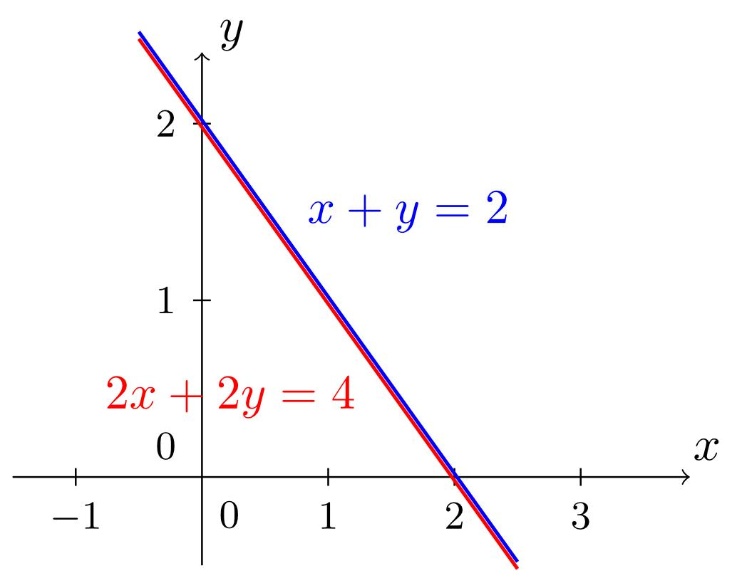

B. Lines defined by equivalent equations
# Source: AI Source: Provided by: [Data Path: Persons Table -> ID Column: 1, Name_En Column: Motasem Essam] -> From: [ChatGPT] on [7/25/2026]
The equations $y=2x+1$ and $2y=4x+2$ describe the same line. Although the equations look different, their solutions are identical.
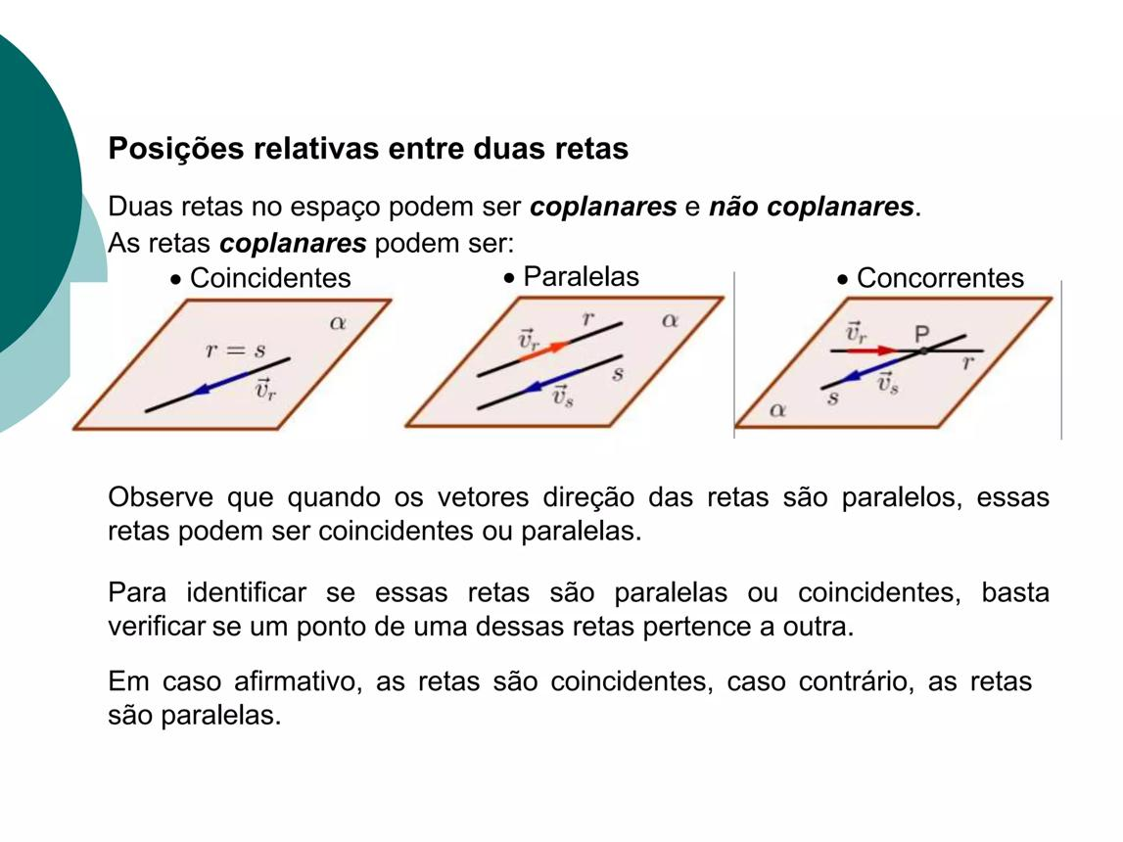

C. Coincident lines in three-dimensional space
# Source: AI Source: Provided by: [Data Path: Persons Table -> ID Column: 1, Name_En Column: Motasem Essam] -> From: [ChatGPT] on [7/25/2026]
Two vector equations may use different starting points and direction vectors while representing exactly the same infinite line in space.

Mathematical Representation

A. Vector equations
# Source: AI Source: Provided by: [Data Path: Persons Table -> ID Column: 1, Name_En Column: Motasem Essam] -> From: [ChatGPT] on [7/25/2026]
A line in three-dimensional space can be represented by
$$L_{1}:r=a+tu$$
A second line can be represented by
$$L_{2}:r=b+sv$$
where $a,b$ are position vectors, $u,v$ are direction vectors, and $t,s∈R$.
The lines are coincident if:
1. Their direction vectors are parallel:
$$v=ku, k≠0$$
2. The displacement between their starting points is parallel to the same direction:
$$b-a=mu$$
for some real number $m$.
These conditions mean that both equations describe the same infinite straight line.

B. Set notation
# Source: AI Source: Provided by: [Data Path: Persons Table -> ID Column: 1, Name_En Column: Motasem Essam] -> From: [ChatGPT] on [7/25/2026]
If $L_{1}$ and $L_{2}$ are coincident, then
$$\boxed{L_{1}=L_{2}}$$
and therefore
$$\boxed{L_{1}∩L_{2}=L_{1}=L_{2}}$$
Their intersection contains infinitely many points.

C. Distance between coincident lines
# Source: AI Source: Provided by: [Data Path: Persons Table -> ID Column: 1, Name_En Column: Motasem Essam] -> From: [ChatGPT] on [7/25/2026]
The minimum distance is
$$\boxed{d=0}$$
because every point on one line is also on the other.

Worked Mathematical Examples
# Source: AI Source: Provided by: [Data Path: Persons Table -> ID Column: 1, Name_En Column: Motasem Essam] -> From: [ChatGPT] on [7/25/2026]
Example 1: Coincident lines with different equations
Consider
$$L_{1}: y=2x+1$$
$$L_{2}: 2y=4x+2$$
Divide the second equation by $2$:
$$y=2x+1$$
Both equations are identical after simplification.
Conclusion: The lines are coincident.
Example 2: Coincident lines in three-dimensional space
Consider
$$L_{1}:\left(x,y,z\right)=\left(1,2,3\right)+t\left(2,1,0\right)$$
and
$$L_{2}:\left(x,y,z\right)=\left(5,4,3\right)+s\left(2,1,0\right)$$
The direction vectors are identical:
$$u=v=\left(2,1,0\right)$$
The difference between the starting points is
$$\left(5,4,3\right)-\left(1,2,3\right)=\left(4,2,0\right)$$
Since
$$\left(4,2,0\right)=2\left(2,1,0\right)$$
the second starting point lies on the first line. Both equations therefore describe the same line.
Conclusion: $L_{1}$ and $L_{2}$ are coincident.
Example 3: Distinguishing coincident and parallel lines
Consider
$$L_{1}:\left(x,y,z\right)=\left(0,0,0\right)+t\left(1,0,0\right)$$
$$L_{2}:\left(x,y,z\right)=\left(0,2,0\right)+s\left(1,0,0\right)$$
Their direction vectors are equal, but their starting points differ by $\left(0,2,0\right)$, which is not a multiple of $\left(1,0,0\right)$.
The lines have the same direction but occupy different positions.
Conclusion: They are distinct parallel lines, not coincident lines.

How to Determine Whether Two Lines Are Coincident
# Source: AI Source: Provided by: [Data Path: Persons Table -> ID Column: 1, Name_En Column: Motasem Essam] -> From: [ChatGPT] on [7/25/2026]
Use these steps when comparing two lines in three-dimensional space.
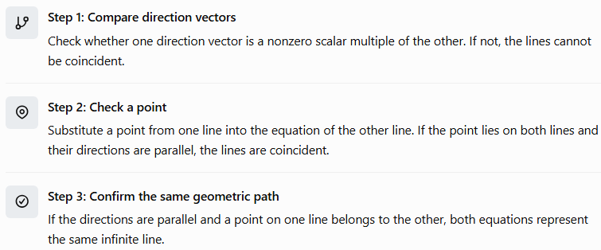
Step 1: Compare direction vectors
Check whether one direction vector is a nonzero scalar multiple of the other. If not, the lines cannot be coincident.
Step 2: Check a point
Substitute a point from one line into the equation of the other line. If the point lies on both lines and their directions are parallel, the lines are coincident.
Step 3: Confirm the same geometric path
If the directions are parallel and a point on one line belongs to the other, both equations represent the same infinite line.

Comparison with Other Types of Lines
# Source: AI Source: Provided by: [Data Path: Persons Table -> ID Column: 1, Name_En Column: Motasem Essam] -> From: [ChatGPT] on [7/25/2026]
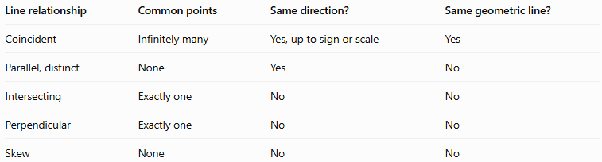
Line relationship | Common points | Same direction? | Same geometric line?
Coincident | Infinitely many | Yes, up to sign or scale | Yes
Parallel, distinct | None | Yes | No
Intersecting | Exactly one | No | No
Perpendicular | Exactly one | No | No
Skew | None | No | No
Important distinction: Coincident lines and distinct parallel lines have the same direction, but coincident lines also share every point.

Applications of Coincident Lines
# Source: AI Source: Provided by: [Data Path: Persons Table -> ID Column: 1, Name_En Column: Motasem Essam] -> From: [ChatGPT] on [7/25/2026]
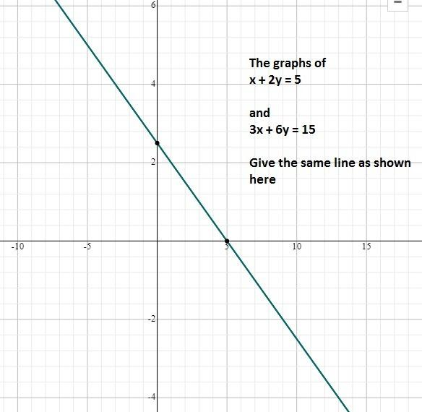
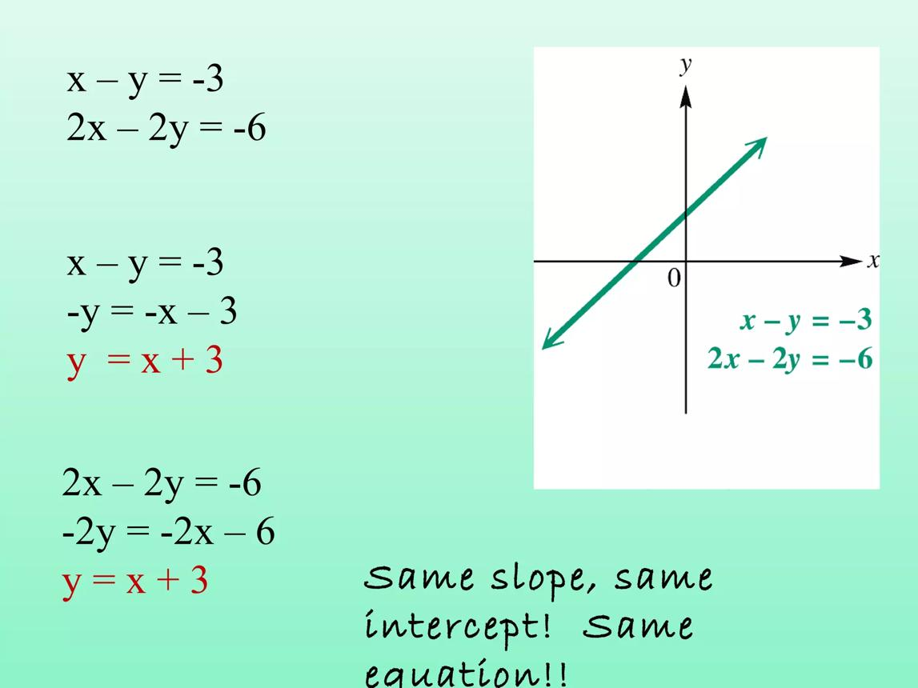
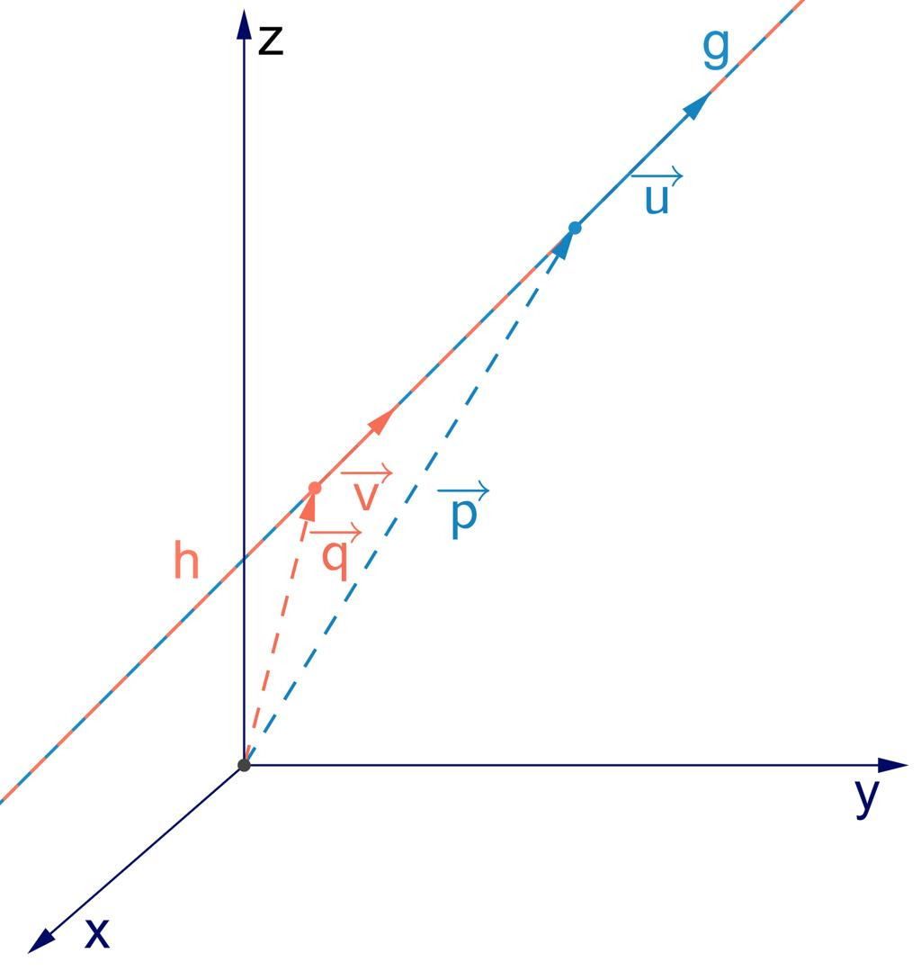
Coincident lines are useful in:
- Coordinate geometry: Recognizing equivalent line equations.
- Computer-aided design (CAD): Identifying overlapping geometric entities.
- Engineering: Verifying whether two descriptions represent the same axis or straight component.
- Computer graphics: Detecting duplicate geometric objects.
- Analytical geometry: Determining whether two line equations have infinitely many common solutions.

Key Points
# Source: AI Source: Provided by: [Data Path: Persons Table -> ID Column: 1, Name_En Column: Motasem Essam] -> From: [ChatGPT] on [7/25/2026]
- Coincident lines occupy exactly the same geometric position.
- They share infinitely many points.
- They have parallel direction vectors.
- A point on one line must also lie on the other.
- Their minimum distance is zero.
- Coincident lines are different representations of one geometric line, not two distinct parallel lines.
- In three-dimensional space, coincident lines are always coplanar.

Conclusion
# Source: AI Source: Provided by: [Data Path: Persons Table -> ID Column: 1, Name_En Column: Motasem Essam] -> From: [ChatGPT] on [7/25/2026]
Coincident lines are lines that represent exactly the same straight path in space. Their equations may look different, but simplifying or comparing their vector representations reveals that they share every point. Understanding coincident lines helps distinguish them from parallel, intersecting, perpendicular, and skew lines in solid geometry.

